**Menu Page Design**

**Elements:**

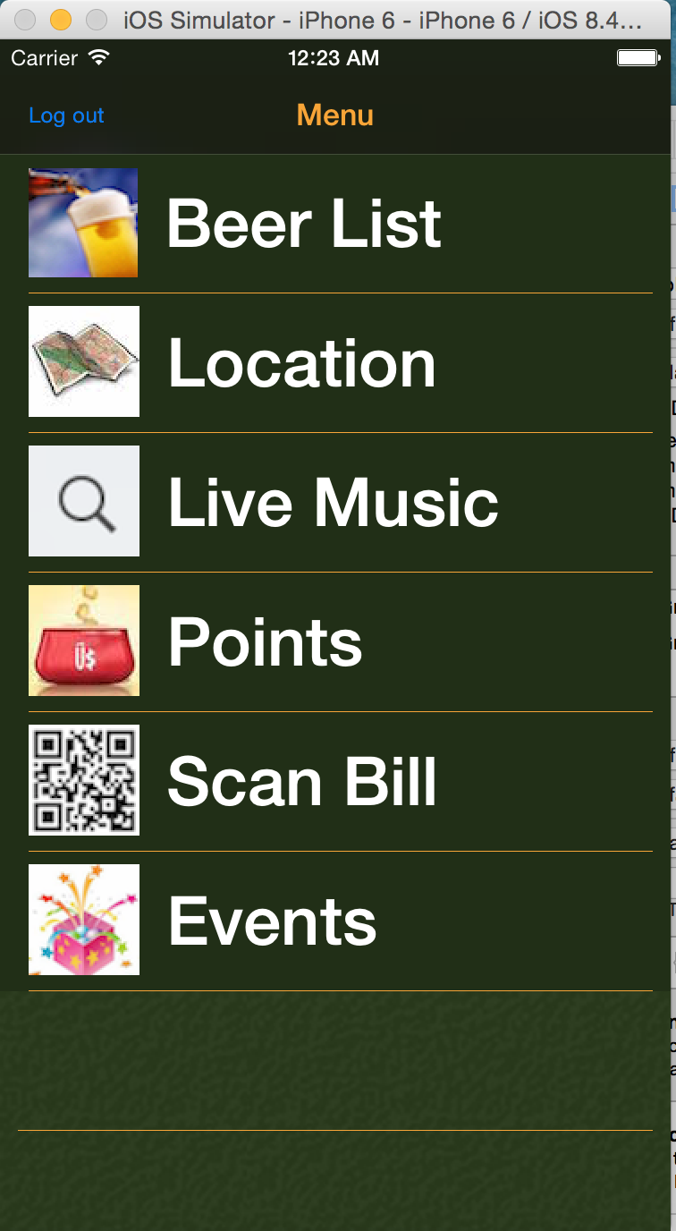

Title: Menu, orange

View Backgroud: black

“Log out” button:

log out account and back to the login page

Cell Background: dark green(the same as the website)

Cell image:

On the left of every cell

Cell content:

White, 50

“Beer List” ,”View On Map”, “Location”, “Live Music”, “Points”, “Scan Bill” and “Events”

Cells Separator: yellow single line